

**Sample Abstract of NAMOR ‘24: Information for Authors**

First Author1*, Second Author2, Third Author1 (12-point)

*1First Affiliation*

*2Second Affiliation* (if different)

*\*abc@defg.hij.ac.jp* (Corresponding author, 10-point)

Abstracts are limited in length to one page.

The total width of the abstract must not exceed 16.5 cm (6.5 inches); the height is limited to 23.5 cm (9.2 inches). For A4 paper, the abstract should have 22.5 mm margins on each side and 31 mm margins top and bottom. The complete printed area including title, authors, text, figures and references must fit within these margins. Please use this Word file as a template.

The **Title** (in 14-point Times New Roman, bold) should be centered at the top of the page. The title should be followed by the authors’ names, and in the case of multiple authors, the presenter’s name should be indicated by an underline. The names should be followed by the author affiliations, including complete addresses, in italic type, with one affiliation per line. The e-mail address of the corresponding author (indicated by an asterisk (*) next to the name) should be given after the list of affiliations. Authors and main text should be in 12-point Times New Roman; affiliations and the contact e-mail should be in 10-point Times New Roman. The authors, affiliations, and contact e-mail should be centered, and the main text should be justified. Use single spacing throughout the document but insert a blank line between the title and authors, as well as between the contact e-mail and the text. References within the text should appear in square brackets [1]. Figures and tables must be inserted at the proper position and size within the text and with proper captions.

Please include the presenter’s name in the file name.

In order to avoid printing problems caused by the file format, you can convert your abstract into PDF format (with size not exceeding 10MB) and upload it on the registration form available on the official web site (<https://namor.sites.lngs.infn.it/>) before April 20th, 2024.

Fig. 1. Test Figure. (10-point)

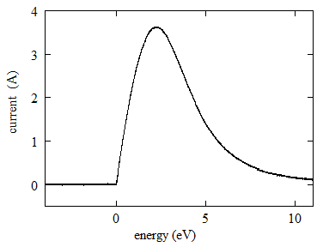

Table 1. Test table (10-point)

|  |  |  |
| --- | --- | --- |
| **Test** | **Table** | **Value** |
| 1 | 6 | 11 |
| 2 | 7 | 12 |
| 3 | 8 | 13 |
| 4 | 9 | 14 |
| 5 | 10 | 15 |

**References** (optional, 10-point)

[1] A.B. Sample *et al*, Phys. Rev. Lett. xx (19xx) xxxx.